LAB ASSIGNMENTS 3: AWS RDS and DynamoDB

AWS RDS
Amazon Relational Database Service (Amazon RDS) is a web service
that makes it easier to set up, operate, and scale a relational database in the AWS Cloud.
It provides cost-efficient, resizable capacity for an industry-standard
relational database and manages common database administration tasks.

Explore RDS services and costing and when to use which service

Instruction:
1. go to rds service choose freetier mysql
2. provide DB instance identifier for example mydbraj12345id
3. provide db name rajdb root root1234
4. Integrate with Spring boot

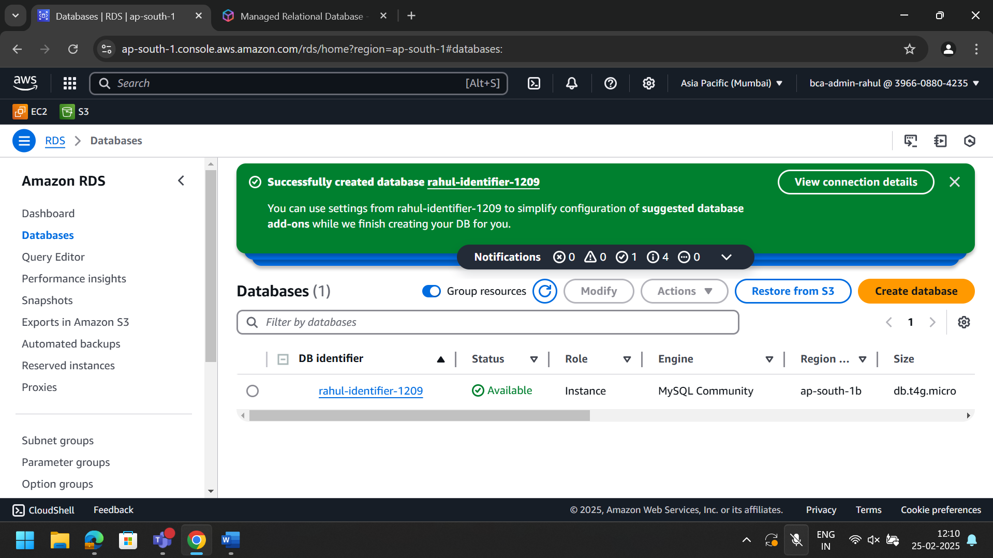
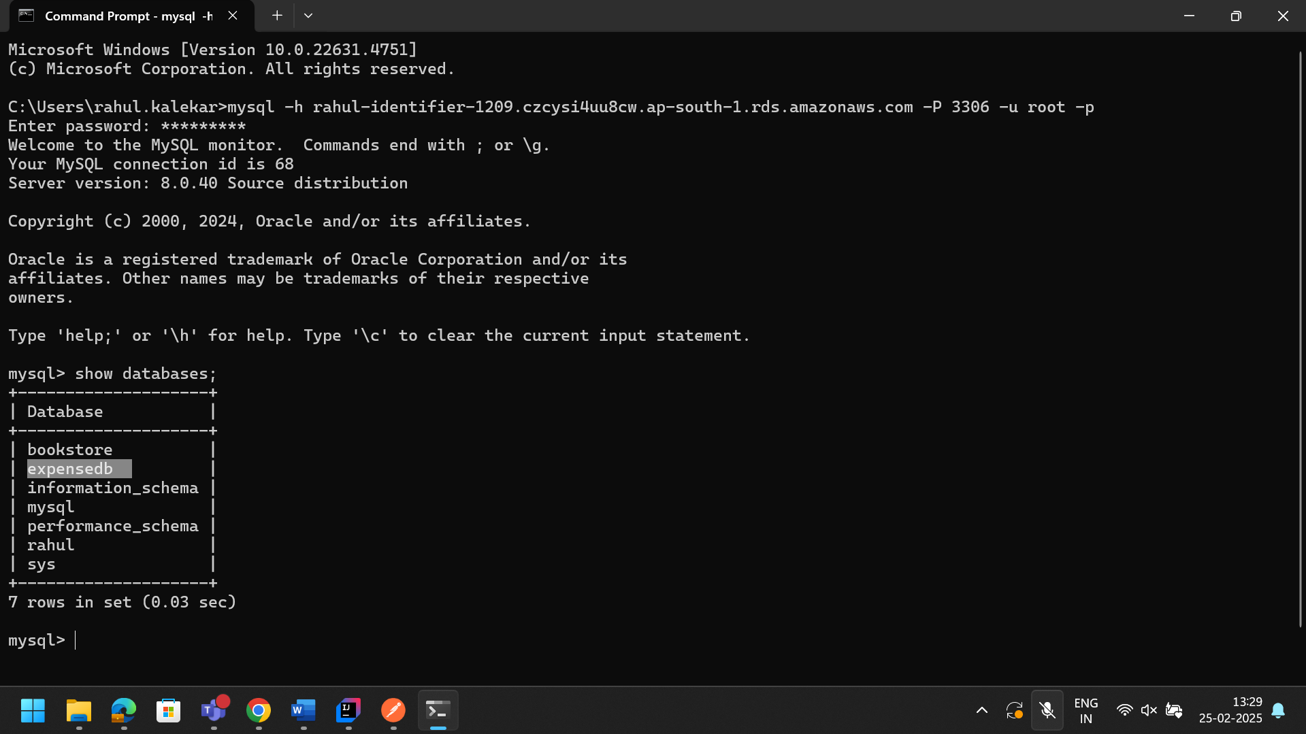

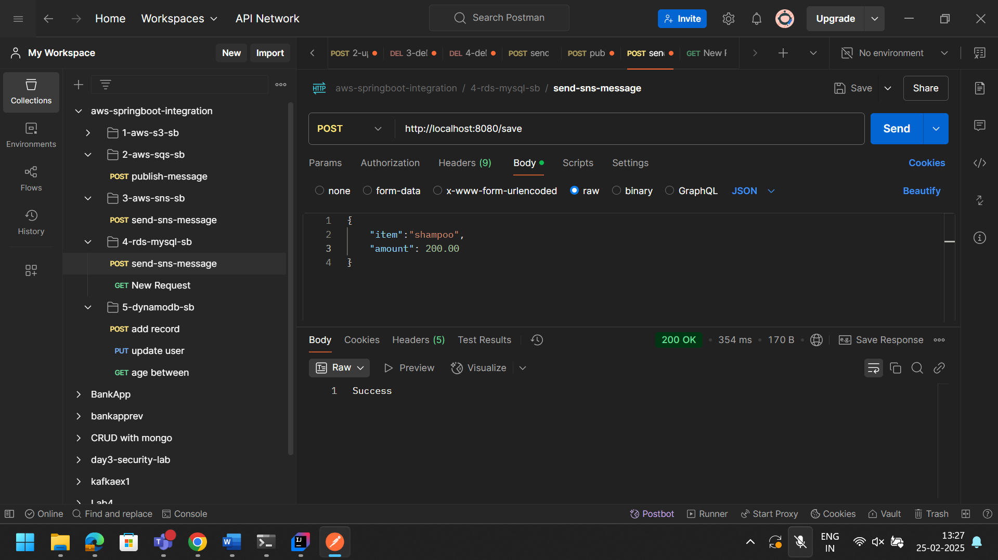

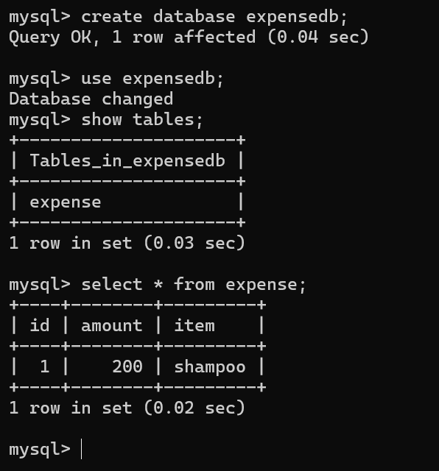

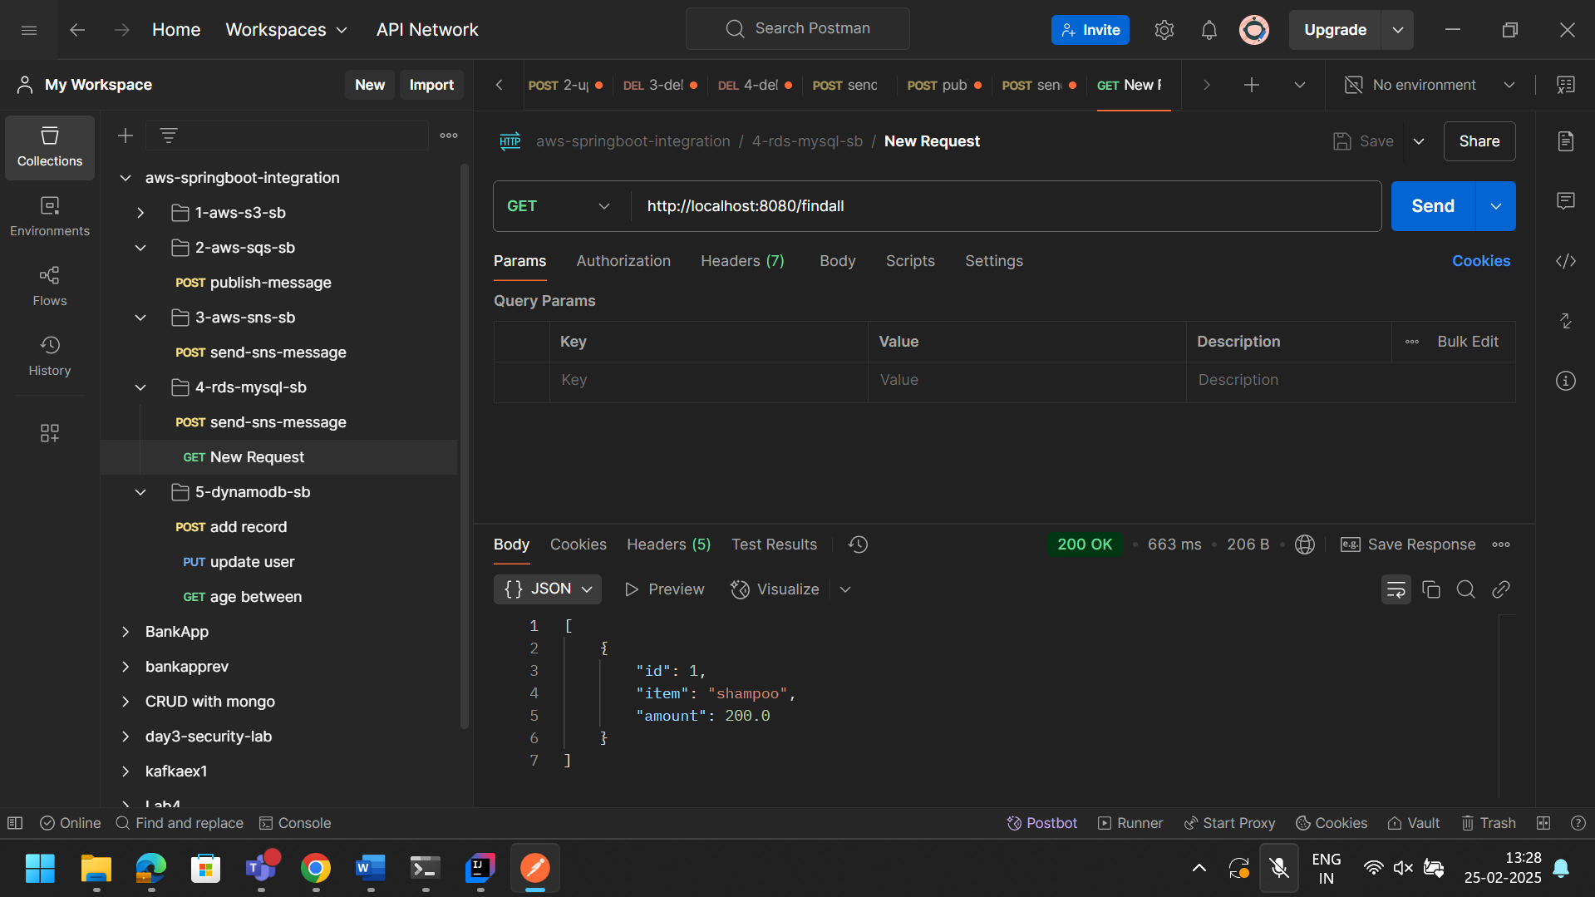

DynamoDB
Amazon DynamoDB is a database service from Amazon Web Services (AWS)
that stores and retrieves data in key-value pairs.
It's a NoSQL database that's cloud-native, meaning it only runs on AWS.

Instruction:
Example : creating dynamodb table and running with spring boot application

